

DUT Name | {{model_name}} – [ {{dut_name}} ]
DUT Part number | {{part_number}}
DUT Rev & Checksum | {{dut_rev}} – {{dut_checksum}}
Testing person | {{test_person}}
Automted Test Report – Generated by PowerSafe-X – DIN R&D TPS
{{test_date}}
Automated Test Report

Test Report Summary
Sl No | Test Name | Result
{%tr for t in tests %}
{{ t.sNo }} | {{ t.name }} | {{ t.result }}
{%tr endfor %}

{% for t in items %}

Test Item {{ t.sNo }}: {{ t.name }}
{{Test_description}}
Test Spec:
- Input voltage =
- Output load =
Test Summary
- Test condition 1 : <<Test condition>>
- Test condition 2 : <<Test condition>>
- Test condition 3 : <<Test condition>>
- Test condition 4 : <<Test condition>>
Test condition 1 : Scope out  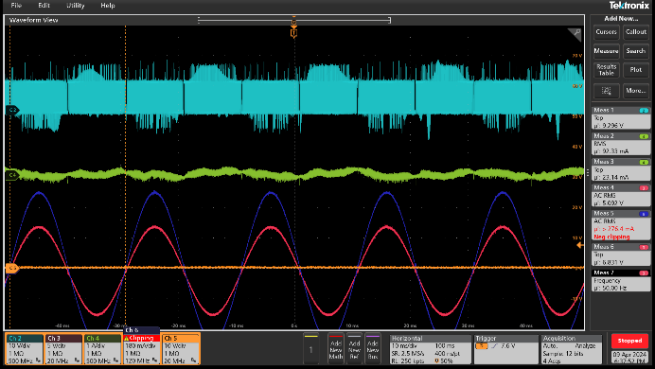 | Test condition 2 : Scope out
Test condition 3 : Scope out | Test condition 4 : Scope out

Timestamp: XXXXXXX
Test Result: {{ t.result }}

{% endfor %}
Test log
{{Log_with_timestamp}}

